Event Name | The Asia Pacific Society of Cardiovascular and Interventional Radiology 2025 (APSCVIR 2025)
Industry | Medical - Gastroenterology
Average Attendance | 800 pax
Open Year | 1993
Frequency | annually
Rotation Area & Pattern | APAC
Duration of Event | 3 days
Preferred Month | March-Jun
Preferred Venue | Hotel with convention facilities or Convention Centre
Break Out Rooms | 5-7
Size of Rooms | 50 – 800 pax
Info on Last / Upcoming Events
Event History
(only if no ICCA record, otherwise, please delete)
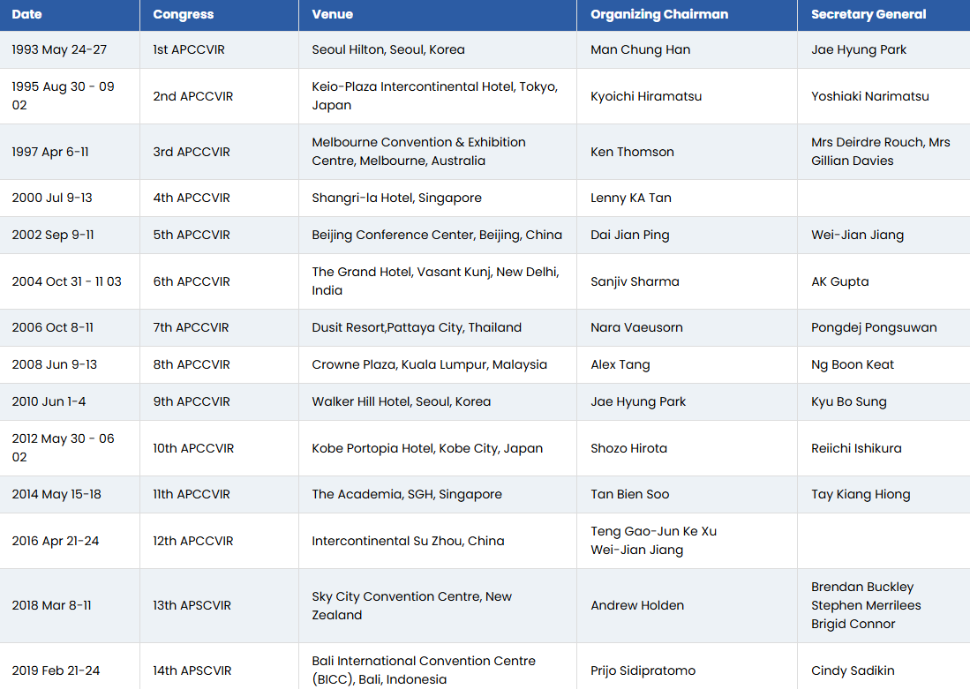
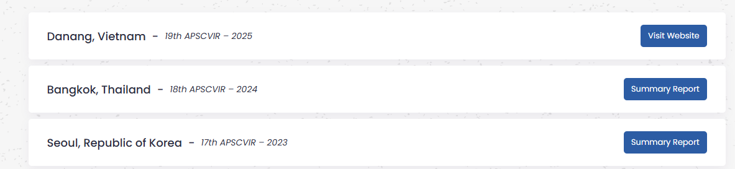
Delegates Profile | Doctors & scientists
International Organisation & Local Host Information
Name of International Organisation | Asia Pacific Society of Cardiovascular and Interventional Radiology
Website | https://www.apscvir.com/
Organisation Profile | One of the most active Medical organization in Vietnam
Name of Local Host / Member | Professor VU DANG LUU  VP & General Secretary of VSRNM
Website | vnage.vn
Organisation Profile | VIETNAM ASSOCIATION OF RADIOLOGY AND NUCLEAR MEDICINE
Local Strengths & Weaknesses | For Vietnam, local host play a key role in selection of destination & venues since the country has not yet been exposed to large international conferences.  One of the most active Medical organization in Vietnam
Bidding Information
Decision Maker | Local host
Decision Making Process | Local host work with DMC  DMC sorting venues & have site inspection  Close destination & venues
Key Bid Criteria | Venu capacity & breakout rooms  Connectivity
Competitors
Competitive Analysis | Previous & current bid
Host Responsibility | Organising Committee, responsible for selection of destination, venue and event plan
Other Information
